CS2S567 Professional Practice and Employability:
Team Based Software Development Workshop

Portfolio

By
Jessica Fealy, 18024092

Team Number | 2
Team Task | Create a PIM system
Own role(s) and tasks in Team | Role:  Week 1 – 5 Team Organiser  Documentation  Programmer  Tasks:  Writing team portfolio weeks 1 – 5  Writing LESPI  Creating flowchart  Researching Tkiner and SQLite

Contents
Contents 2
Weeks 1 & 2 3
Weeks 3 4
Weeks 4 5
Personal QA/ISSUE TRACKING Activity Overview Log 6
Appendix 9
Appendix 1 – GUI Plan 9
Appendix 2 – Discord creation 9
Appendix 2 – Team meetings time discussed 10
Appendix 3 – Spoken about what tasks are required to be completed 10
Appendix 4 – Trello board 11
Appendix 5 – Team work assignment 11
Appendix 6 – Week 4 work assignment 11
Appendix 7 – Week 4 Trello board 12
Appendix 8 – Slide show discussion 12
Appendix 9 – Week 4 programminglab 12

Weeks 1 & 2 | Project Setup
Author: Jessica | Team | Own
Activities undertaken | I wrote this week team portfolio which can be found:  https://github.com/BenB33/ProfessionalismTeam2/blob/main/Team%20work/Team%20Portfoilo.odt  And which I have submitted with this portfolio | Created and annotated a GUI mock-up for how each component will work
Outcome of QA activities |  | Tried to create first simple interface with buttons and user input fields
Activities resulting from QA process |  | I created a discord channel for our team to talk and work together adding all members.  I began adding tasks we needed to complete.  I assigned members for the team work to do.
Personal QA development | Researched how to create a basic interface with limited usability.  Researched how to incorporate a database / CVS file with python  Learning each members abilities and how to assign them to work which will best suit their strengths
Evidence of own activities | Appendix 1 – GUI plan  https://github.com/BenB33/ProfessionalismTeam2/blob/main/Jessica/GUI%20PLAN.tif  Appendix 3 – Trello board  Appendix 4 – Discord creation  Appendix 5 – Teamwork assignments

Weeks 3 | Project Setup
Author: Jessica | Team | Own
Activities undertaken | I wrote this week team portfolio which can be found on the GitHub link found on Week 1, and which I have submitted with this portfolio | For the past 2 weeks I have written the LESPI and started on the quality assurance document.  I have also been working with myprogramminglab.  Ben and I had set up a time to meet to discuss the content required for the quality assurance document.  I have also been researching how to use SQLite with python
Outcome of QA activities |  | The LESPI has been written and the I have gained further understanding of python, TKinter and SQLite
Activities resulting from QA process |  | To further complete the quality assurance and to continue researching Tkinter and SQLite
Personal QA development | Written LESPI talking specifically talking about the computer misuse act and GDRP with Ufix policies on these.  Researched how to create tables and attributes using SQLite and python
Evidence of own activities | LESPI Document – GitHub link  https://github.com/BenB33/ProfessionalismTeam2/blob/main/Jessica/user%20gui.odt

Weeks 4 | Project Setup
Author: Jessica | Team | Own
Activities undertaken | I wrote this week team portfolio which can be found on the GitHub link found on Week 1 | Assigned team members to work on.  Continued work on myprogramminglab to chapter 4.5
Outcome of QA activities |  | Trello board has been updated
Activities resulting from QA process |  | To continue work on myprogramminglab  To work with Komal in doing the flowchart  Finish my slides for seminar
Personal QA development | Speaking to the team members to help detail the work they have been assigned over the past 4 weeks and what they can talk about and evidence they can show for their work on the seminar
Evidence of own activities | Appendix 6 – Week 4 work assignment  Appendix 7 – Week 4 Trello board  Appendix 8 – Slide show discussion  Appendix 9 – Week 4 programminglab

Weeks 5 | Project Setup
Author: Jessica | Team | Own
Activities undertaken | Ben work from this week his team portfolio can be found using the same link found on week 1, and which I have submitted with this portfolio | As my last week being team leader, I assigned people to do their slides for the seminars and chased them up to ensure they were done in a timely manner. Once all slides are completed, I got Ben to add animations and transitions to the slides.  I done the functionality flowchart, SQLite research, and LESPI slides. Fully voiced over and images
Outcome of QA activities |  | Team members began and completed their slides and as a team we watched through the slides to find any issues
Activities resulting from QA process |  | Seminar slides were completed
Personal QA development | Recording and editing audio for powerpoint presentations  Learning how to keep all team members to a schedule and chasing team members up for their slides to be completed  Reviewing slides with team members to discuss depth they have gone into and way they could improve the slides before submission
Evidence of own activities | Appendix 10 – My slides

Weeks 6 & 7 | Project Setup
Author: Jessica | Team | Own
Activities undertaken | Ben work from this week his team portfolio can be found using the same link found on week 1 | Throughout this week I had reviewed and submitted our teams comments for the feedback of the teams who had submitted their work. I also continued research on how to develop forms using tkinker.  And to continue work on myprogrammingklabs
Outcome of QA activities |  | Teams who had submitted their work in this period had their work reviewed and commented upon.  Progress has been made with understanding, namely on how different buttons and text boxes interact
Activities resulting from QA process |  | Further research on how grids can be used to effectively used to make the forms look more appealing  Team leader ben has asked me to begin work on the prototype
Personal QA development | Continued work onto myprogamming labs, many of the first chapters have been completed  A very basic form has been completed which looks like a log in screen
Evidence of own activities | Appendix 11 – Very basic slides

Weeks 8 | Project Setup
Author: Jessica | Team | Own
Activities undertaken | Ben work from this week his team portfolio can be found using the same link found on week 1 | Began working on the prototype for the project. Have completed a rudimentary log in screen, without any data being pulled from the databases.  All buttons, list boxes, and text box has been created with their function calls which haven’t been completed.  No data is yet being pulled from the databases
Outcome of QA activities |  | Need team assistance to create and pull data from database.  Need to continue work on the appearance of the data form  Need to create functionality of for the buttons
Activities resulting from QA process |  | At the next team meeting after the Christmas period in the team meeting I will discuss what I have achieved and how much more is left to complete
Personal QA development | Created the first prototype for the solution  Have points which need to be raised with team members
Evidence of own activities | Appendix 12 – First prototype

Personal QA/ISSUE TRACKING Activity Overview Log

Issue | Week  date | Activities undertaken | Outcome of QA Activities | Activities resulting from QA Process | Personal QA development
1 | 1 | Created discord for all team members to use to communicate | All team members added to the channel | Assigned work for all team members to attempt before next meeting | N/A
2 | 1 | During the first week we discussed and summarised what we believe we had to be doing to create the PIM | We had a path where to go with the project | Team members were assigned various tasks based on their skill set
3 | 1 | Updated Trello board with base tasks that we had thought about that we needed to complete | All members were assigned a task on the trello board to work on | In the next meeting we will talk about what each team member was able to complete from their assigned tasks
4 | 1 | Created mock up of how the GUI is intended to look, this is to help guidance in writing the quality assurance doc | Mock up designed where other team mate (Ben) done a visual studio mock up to make sure the design looked how we wanted and was practical | Created a pending process to created the quality assurance document | N/A
5 | 2 | Creatingbasic form using python and tkinter | Struggled with forms and tkinter, will try again in a few weeks | Need to commit to further research of tkinter | From doing this basic task I learnt some areas of python and tkinter which im not familiar and allowed me to do further research
6 | 2 | Began work on myprogamminglab | I have got to answered all questions to chapter 3 on myprogramminglab | Alloting time to do further work on myprogramminglab | N/A
7 | 3 | Researched LESPI principles and what items are required to be included on this | Had an idea and list of ideas that need to be written in the LESPI | To write a first draft LESPI for PIM | Doing this task I learnt the features and laws required to be written in an LESPI
8 | 3 | Wrote the LESPI and email to Shaily to get clarity on if it is down the right lines | Confirmation from Shaily that LESPI looks good, but to explicity mention Computer misuse Act | To write the final draft of the LESPI | N/A
9 | 4 | Begin work on creating my slides for the seminar | Have a rough layout on what I want to talk about | To compete the final look and to voice over my slides | N/A
10 | 5 | Recording audio for the powerpoint slides | Have a script roughly written for what I want to say | Completed audio and add this to the slides. Feedback from shaily about the PowerPoint, next time not to write a script | Not to write a script for the next presentation
11 | 5 | Creating slides for the powerpoint
12 | 5 | Help combining slides together with Ben | All slides have been combined with animations overlayed and audio automatically playing | Powerpoint submitted | N/A
13 | 6 | Going though all work which has been submitted by other teams and submitted feedback | All team should’ve received their feedback from us | As a team we have discussed things we have learned from other teams slides and how we can improve ours in the future | N/A
14 | 6 | Begin work on form creations | Again struggling with creating multiple forms | Need to do further reasearch | Need to look into how buttons and text boxes work, and how to create multiple forms
15 | 6 | Research how to use buttons and text boxes
15 | 7 | Research how to use text boxes to send data to create new windows
16 | 8 | Begin work on prototype
17 | 8 | Finding issues using grids and ensure they look presentable

Appendix

Appendix 1 – GUI Plan

Appendix 2 – Discord creation
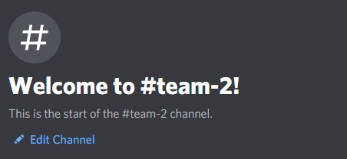

Appendix 2 – Team meetings time discussed
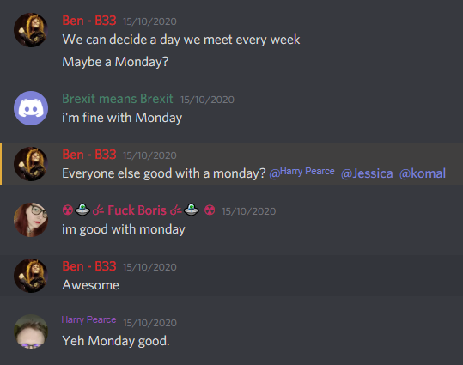

Appendix 3 – Spoken about what tasks are required to be completed
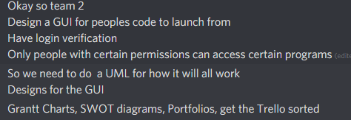

Appendix 4 – Trello board

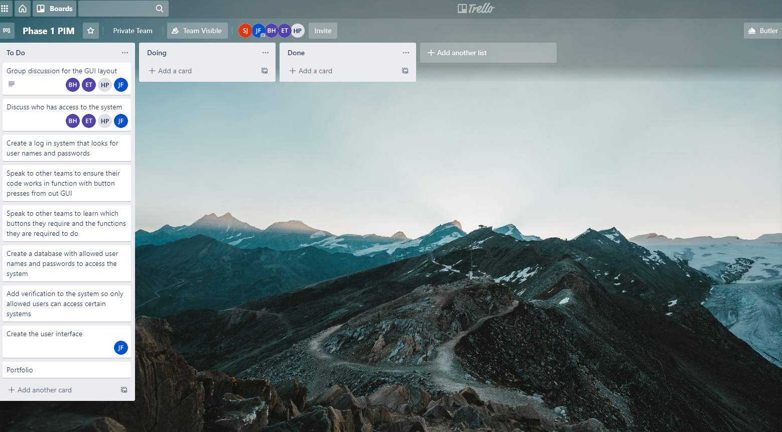

Appendix 5 – Team work assignment
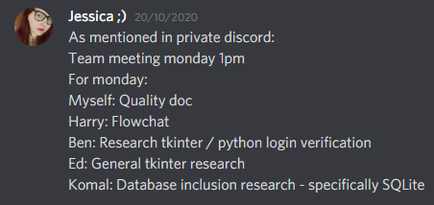

Appendix 6 – Week 4 work assignment

Appendix 7 – Week 4 Trello board
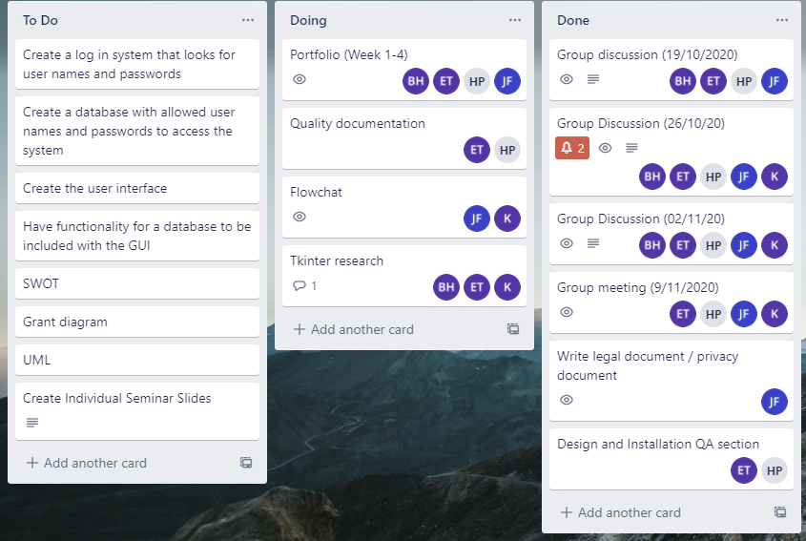

Appendix 8 – Slide show discussion
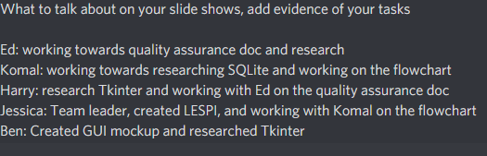

Appendix 9 – Week 4 programminglab
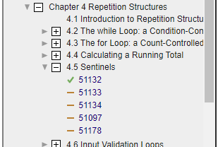

Appendix 10 – My slides
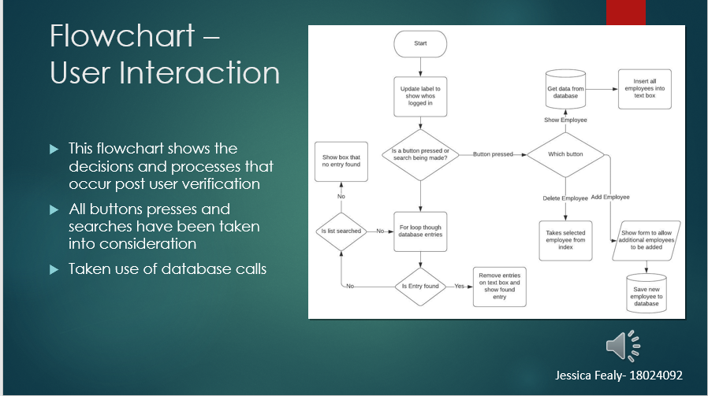
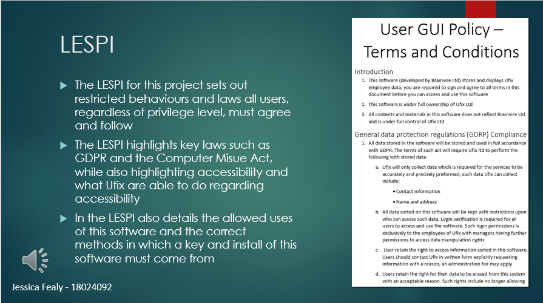
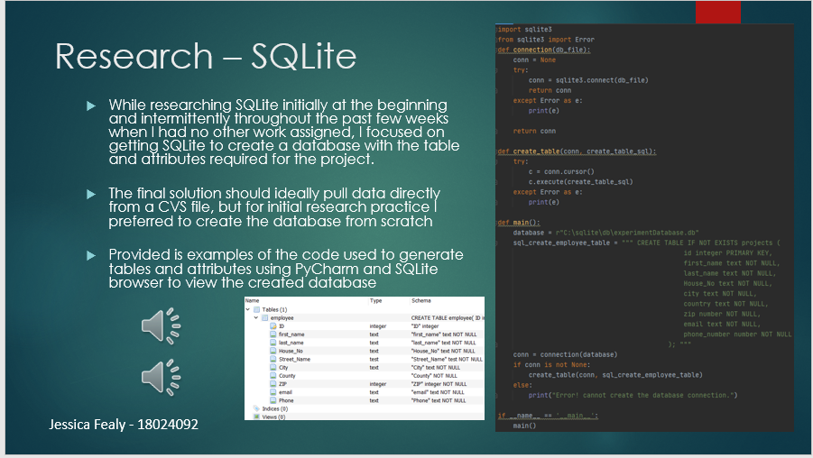

Appendix 12 – First Prototype

